**3 B’s Bee Bee Bee**

**Ready Respectful Responsible**

|  |  |  |  |  |  |
| --- | --- | --- | --- | --- | --- |
| **7 Habits** | All 7 habits! | *Be proactive.  *Sharpen the saw. | *Seek first to understand, then to be understood. | *Synergize  *Think win-win | *Begin with the end in mind.  *Put first things first. |
| Hallways | 4S’s-  Smiling  Straight  Silent  Safe |  |  |  |  |
| Restrooms |  | Only flush what belongs in the toilet. | Use quiet voices.  Give others privacy. | Report any problems to an adult. | Keep walls, stalls, floors, and your body clean.  Get in and out of the restroom promptly. |
| Lunchroom |  | Promptly follow the directions, expectations, and signals of the adults in charge. | Use table manners.  Use soft, inside voices. | Allow others to join your table.  Work as a team to keep it clean. | Eat only your food.  Eat more, talk less. |
| Playground |  | Play safely and appropriately while being aware of your surroundings.  Dress for the weather. | Treat others as you want to be treated. | Be a problem-solver. | Stop at the bell, line up, and listen to the adults. |
| Gymnasium - Assemblies |  | Follow expectations of the presenter. | Be a whole body listener.  Sit on your bottom. | Applaud appropriately to show appreciation. | Enter and exit gymnasium in an orderly manner. |
| Dismissal  (Car Loop) |  | Respond to safety patrol signals and directions. | Be safe.  Keep hands and feet to self. | Pay attention to the arrival of your vehicle. | Know how you are going home. |
| Dismissal (Bus lines) |  | Go directly to your bus line or to your bus. | Use a quiet voice while waiting for your bus. | Follow all directions given by safety patrol and adults. | Stay in your line.  Keep hands, feet, and objects to self. |
| Morning Arrival |  | Come in slowly and quietly.  Stay in your class line (grades K-2). | Follow directions given by adults and safety patrol. |  | Go directly to your classroom, without visiting other teachers. |
| Cafeteria (AM) |  | Sit at table, quietly. | Listen to instructions if there are any given. | Allow others to join your group at a table. | Sit on your bottom with all of your belongings. |
| Bus |  | Inside voice.  Stay in assigned seat, sitting the proper way. | Respond to driver and bus guard signals. | Use manners toward driver and peers.  Pick up trash. | Know your bus stop! |
| Computer Lab |  | Return computer to original login screen.  Keep track of all passwords and logins. | Listen to the directions before you start using the computers. | Work as a team and keep it clean. | Keep track of all belongings.  Treat equipment respectfully. |

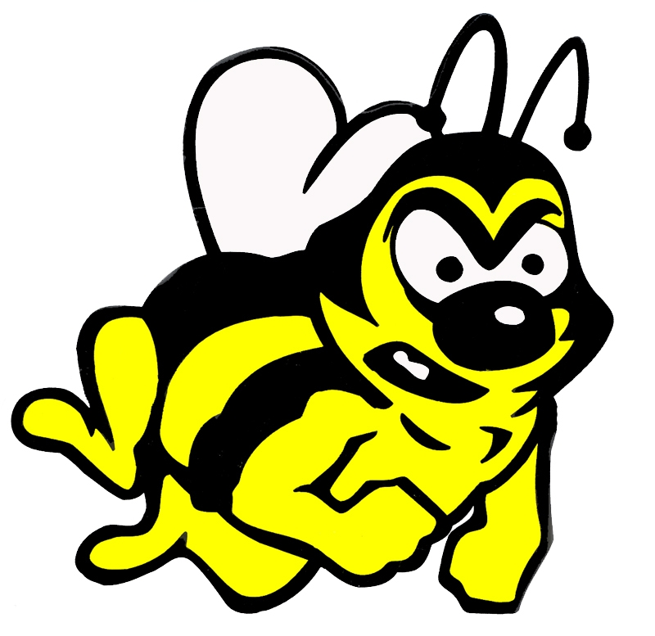

**BEE A LEADER!**